AI for Safety & Productivity in Logistics
Improve logistics throughput by 55% with automated safety and productivity across your supply chain
Siloed tools leave logistics and supply chain operations exposed to risk. viAct unifies AI CCTV, IoT, and wearables into one proactive ecosystem — automatically detecting risks and driving efficiency across operations.
------------------------------------------------------------------------------------------------------------------------------------------

Proven Impact Across Logistic Enterprises
Quantified across warehouses, seaports, airports, and distribution centers.

35% ↑
Increase in Throughput
improving throughput across warehouses and distribution centers in 20+ countries worldwide

30% ↓
Operational Cost Reduction
saving $2M+ annually across warehouse, port, and distribution operations in FY24–25

60% ↑
Faster Incident Prevention
preventing unsafe logistics events annually across warehouses, seaports, and airport operations

------------------------------------------------------------------------------------------------------------------------------------------

Built for 200+ Real Logistic Scenarios
(AI CCTV Use Cases)

Vehicle Near Miss Monitoring
Detect worker proximity to forklifts, pallet trucks, delivery vans, and loading vehicles to reduce collisions and near misses.
Forklift Movement Monitoring
Detect unsafe forklift speeding, reversing, worker proximity, blind spot exposure, and improper pallet loading during movement.
Dock Turnaround Monitoring
Monitor dock activity, vehicle waiting time, and loading delays to improve turnaround efficiency.
Unsafe Loading Detection
Detect unstable pallet stacking, unsafe cargo loading, and improper truck loading across active supply chain dock operations.
Parcel Handling Monitoring
Monitor parcel movement, manual handling, and transfer activity to reduce operational disruptions.
Warehouse Congestion Mapping
Track aisle congestion, dock traffic, and worker movement across warehouse zones to improve supply chain operational flow.

Pre-Built AI Safety Solutions for Every Logistic Risk
Explore ready-to-deploy packages delivering control across logistics and supply chain operations
----------------------------------------------------------------------------

viGent: EHS AI AGENT
Ask viGent about any logistics incident and it responds instantly. Pulling live feeds, flagging dock risks, investigating near-misses, and guiding operations teams to faster, safer decisions across warehouses and supply chains.
----------------------------------------------------------------------------

1. We had forklift and dock worker near-misses more regularly than our incident log showed. viAct started flagging proximity risks we were completely missing. Response times improved and the team now acts before anything becomes serious.
Operations Manager
Distribution Center, Netherlands
2. Loading and unloading violations were our biggest audit risk. Workers skipped steps under time pressure and we couldn't track it consistently. viAct catches these automatically across dock bays. Compliance scores improved within the first quarter.
Warehouse Safety Officer
3PL Facility, Singapore
----------------------------------------------------------------------------
3. Cargo damage was costing us in claims and complaints but pinpointing where it happened was impossible. With viAct, we see exactly where rough handling occurs in the workflow. The team self-corrected and damage rates dropped noticeably.
Supply Chain Manager
E-commerce Warehouse, UAE

4. Congestion in our receiving area was slowing throughput but we couldn't identify the pattern manually. viAct congestion mapping showed exactly where and when bottlenecks formed. We restructured the flow and turnaround times improved across all shifts.
Logistics Director
Cold Chain Facility, Saudi Arabia

5. Forklift speeding was a known issue but impossible to enforce consistently across shifts. Supervisors couldn't be everywhere. viAct flags speed violations and zone breaches in real time. Driver behavior improved and incidents have dropped significantly since.
Fleet Safety Manager
Logistics Hub, Australia

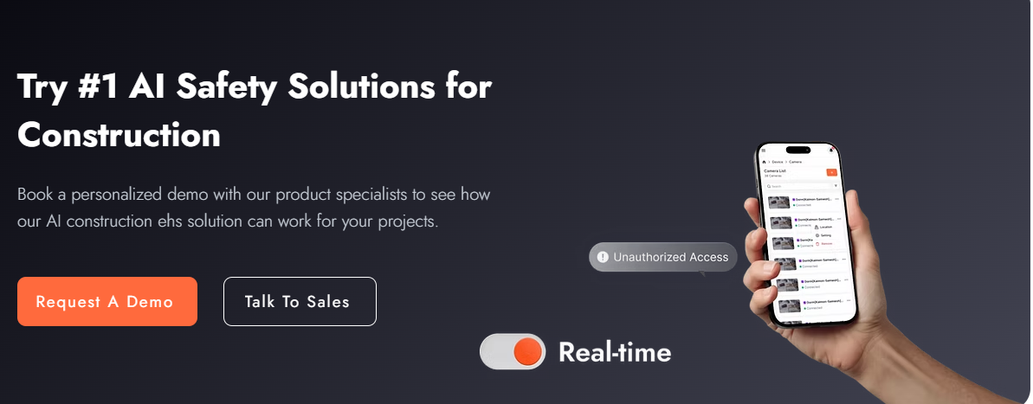
Try Best AI Solution for Logistic & Supply Chain
Book a personalized demo to see how viAct AI can transform safety and productivity across your warehouses, docks, and supply chain.

